SelectFileActivity.java: onOptionsItemSelected:



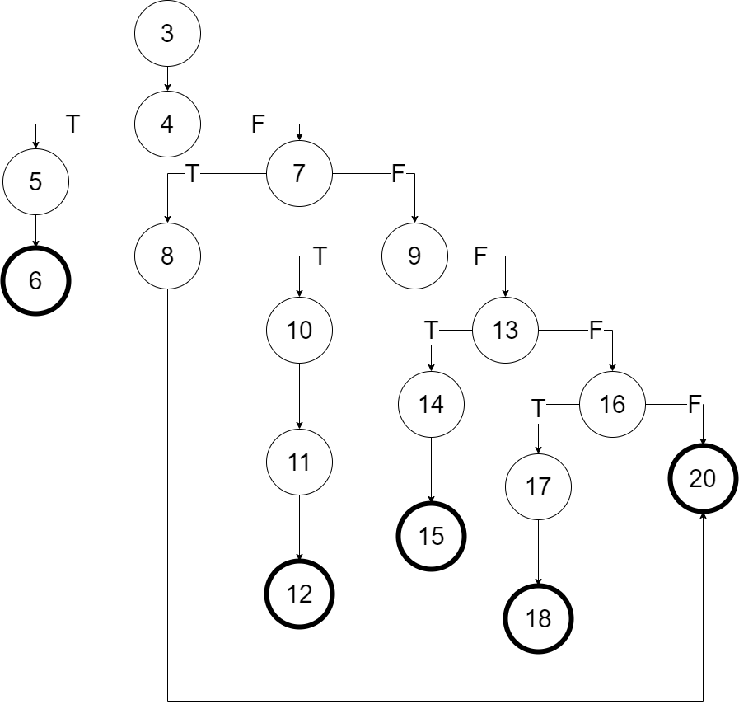

SelectFileActivity.java: onItemClick



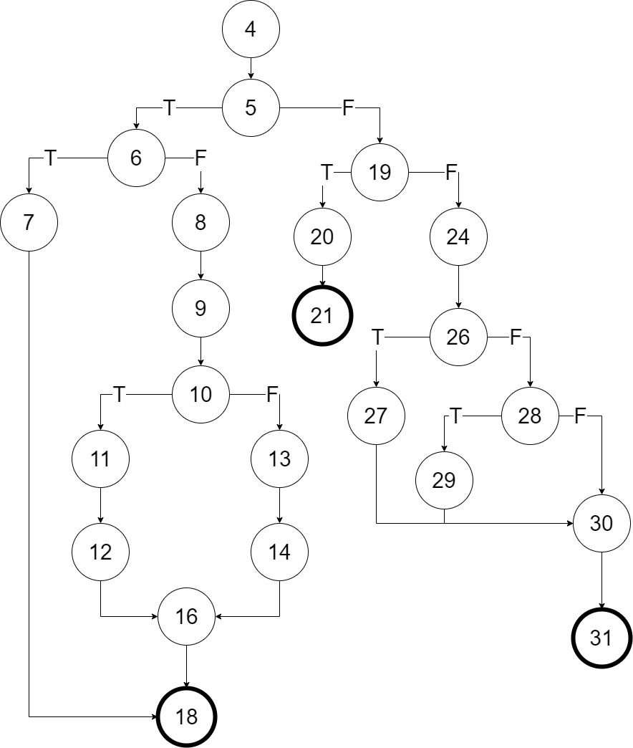

|  |  |
| --- | --- |
| **Test Case ID** |  |
| **Test Case Name** | OnItemClick |
| **Related Use Case ID** |  |
| **Related Test Item** |  |
| **Scope** | Turbo Editor |
| **Input Specification** | 1. Launch Application. 2. Click menu button. 3. Click "Open a file" on menu. 4. Select a folder 5. Click back button 6. Select exiting text file |
| **Output Specification** | 1. Menu displays on the left side of screen. 2. File explorer shows up. 3. The selected folder opens after clicking on it. 4. The file in the folder shows up 5. Go back to previous folder 6. The selected file opens after clicking on it. 7. Content displays on the editor. |

Editor.java: undo



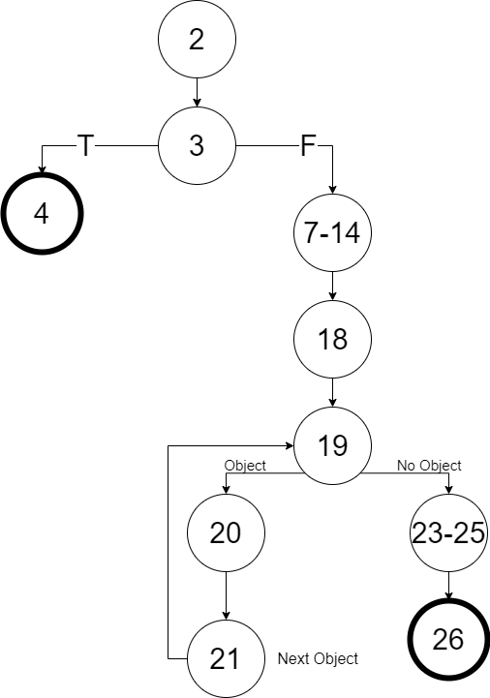

|  |  |
| --- | --- |
| **Test Case ID** |  |
| **Test Case Name** | Undo |
| **Related Use Case ID** |  |
| **Related Test Item** |  |
| **Scope** | Turbo Editor |
| **Input Specification** | 1. Launch Application. 2. Click menu button. 3. Click "Open a file" on menu. 4. Select an existing file to open. 5. Edit content of the opened file. 6. Click undo button. |
| **Output Specification** | 1. Menu displays on the left side of screen. 2. File explorer shows up. 3. The selected file opens after clicking on it. 4. Original content displays on the editor. 5. Change of content displays on the editor. 6. The change is undone after clicking undo button. |

Editor.java: replaceTextKeepCursor



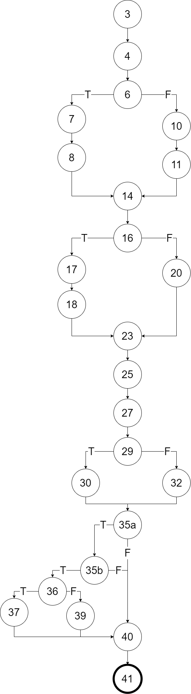

|  |  |
| --- | --- |
| **Test Case ID** |  |
| **Test Case Name** | ReplaceTextKeepCursor |
| **Related Use Case** |  |
| **Related Test Item** |  |
| **Scope** | Turbo Editor |
| **Input Specification** | 1. Launch Application. 2. Click menu button. 3. Click "Open a file" on menu. 4. Select an existing file to open. 5. Highlight some text 6. Enter new text |
| **Output Specification** | 1. Menu displays on the left side of screen. 2. File explorer shows up. 3. The selected file opens after clicking on it. 4. Original content displays on the editor. 5. Highlighted text is replaced by new text |